|  |
| --- |
| **ST XAVIER’S cOLLEGE**  **Maitighar,Kathmandu** |
| **SOFTWARE ENGINEERING** |
|  |
| LAB ASSIGNMENT #5 |
| **Submitted By:**  Aishwarya Rai  ID:014BIM002  **Submitted To:**  Mr. Balkrishna Subedi  Lecturer  Department of Computer Science |

**ER DIAGRAM OF:**

**Ticket Management System:** 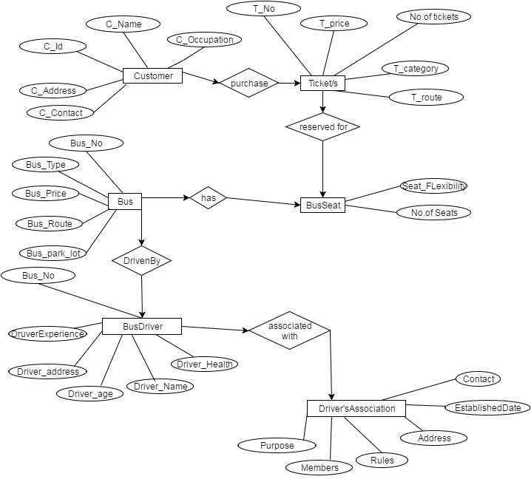

* **Project :**
* 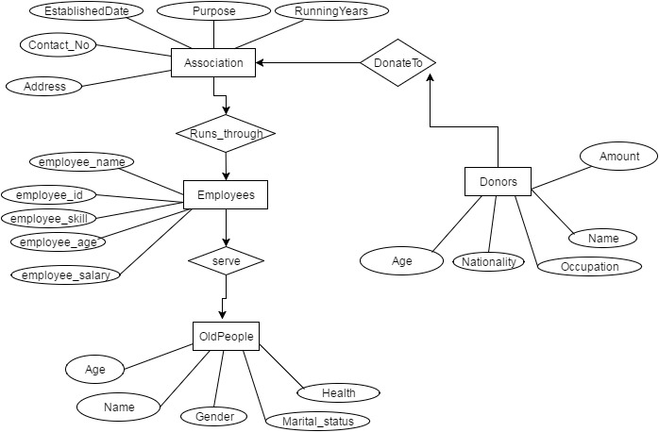

**College Management System:**

